Javascript & React.js

Software’s requirement

* VS Code
* Node.js

Javascript: To add interactivity to your website, things you can do with javascript

* Input validation
* Event Handling
* Pop-up boxes

New features of Javascript (ES6 new features)

Helps to easily write the javascript code, it added lot of modern language syntax

* Keywords like let, const, class, super, extends
* Template strings : ``
* Arrow functions
* Spread & Rest Operators
* Promises
* Async / Await
* Optional Chain(?.)

let & const: They are used to create variables, but earlier javascript used var

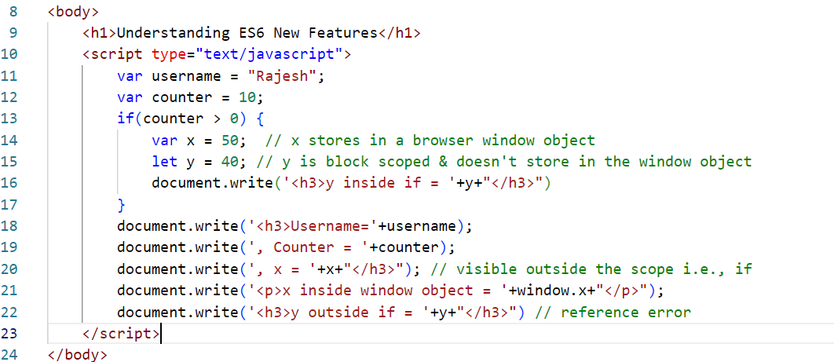

Output:

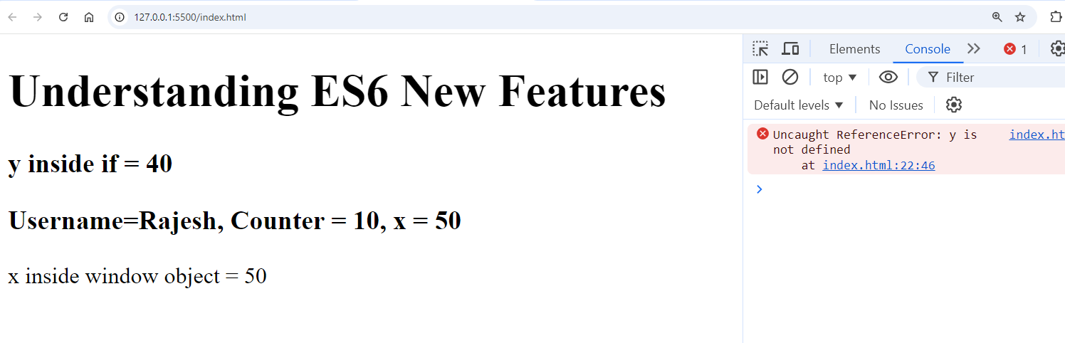

let variables you can modify, const variables you can’t modify

let x = 20;

x = 30; // ok

const y = 50;

y = 55; // error

class:

It is a blueprint of an object, which tells the structure of the object.

Understanding the classes & objects

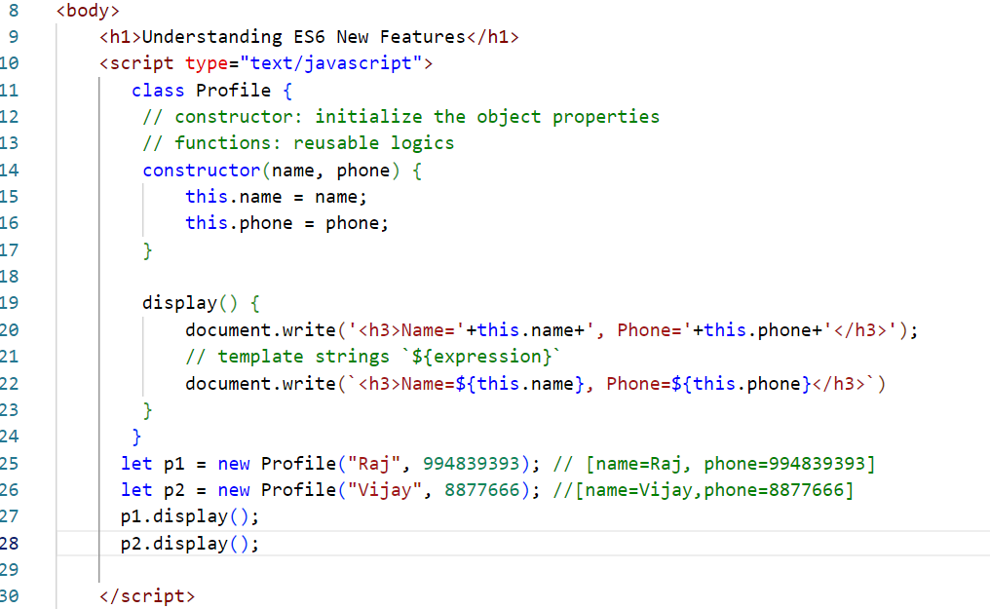

Output:

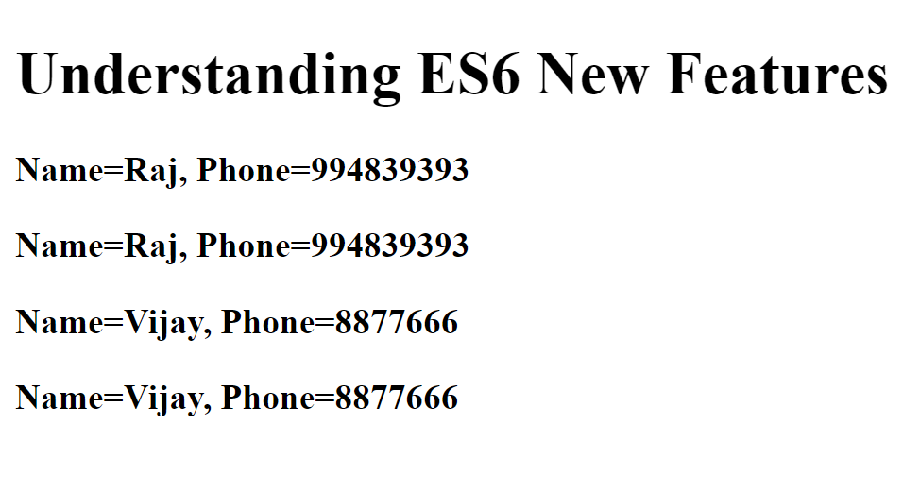

Inheritance

Process of acquiring the properties & behaviors from one object to another object.

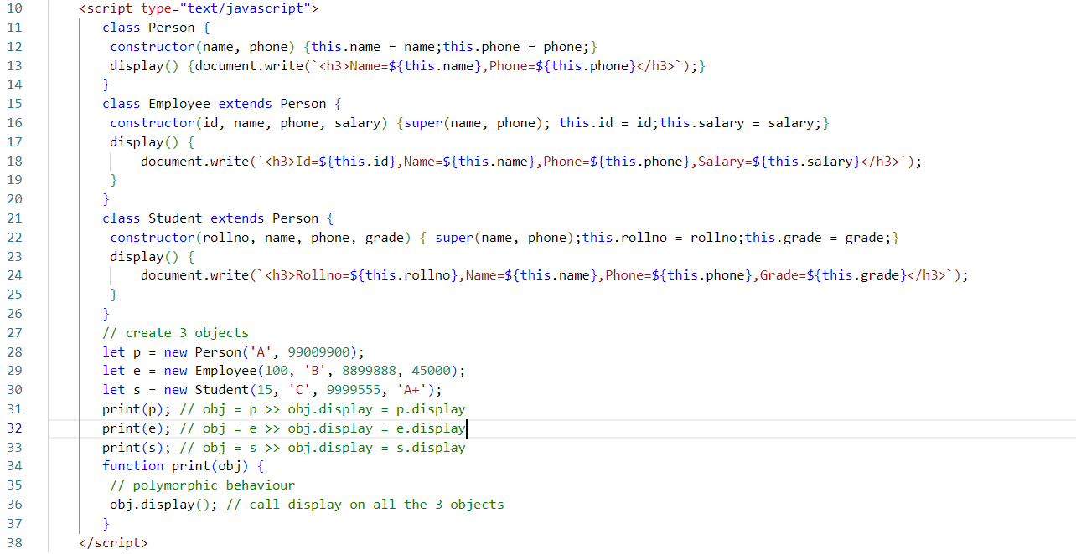

Output:

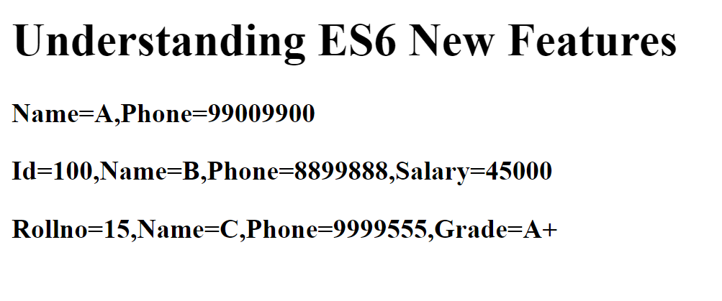

Callback functions

These are the functions which are invoked later depending on some events, like response from the server, events from user interaction, when timeout happens

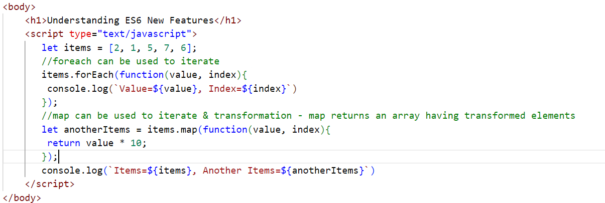

Output:

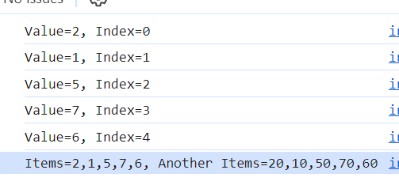

Arrow functions: These are the alternate form for the callbacks, it also simplifies the syntax

Callback:  
function(x, y) {   
 return x * y;  
}  
Arrow function:  
(x, y) => { return x * y ; }  
(x, y) => x * y;

(x, y) => console.log(x, y); // this doesn’t return any thing

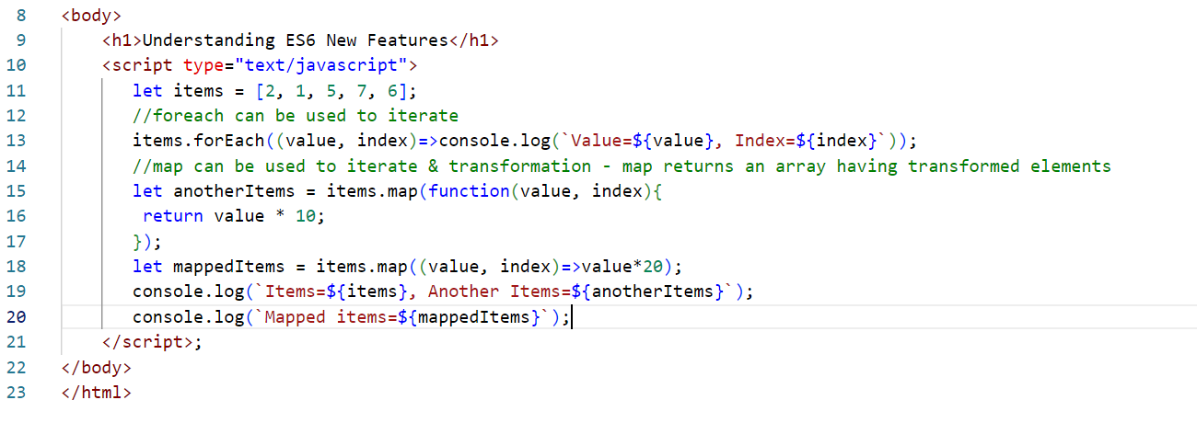

Output:

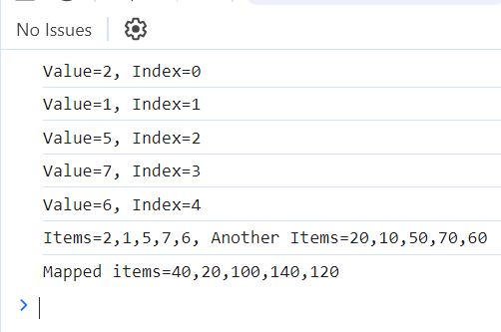

Rest & Spread operators

function add(a, …b) {   
}

Rest parameter can accept 0 or more elements

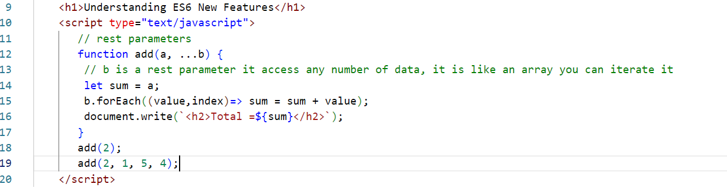

Output:

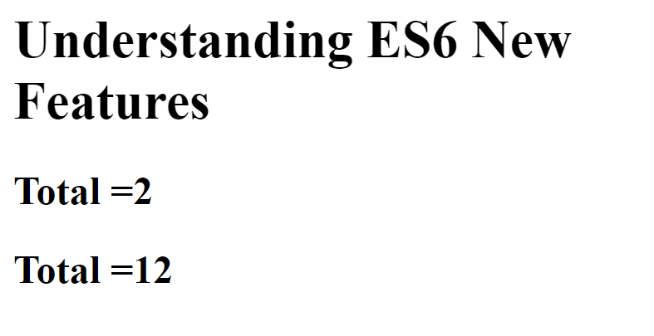

Spread parameter:  
It helps in distributing the elements into multiple parameters

let items = [2, 5, 6];

function test(a, b, c) { }  
test(…items); // a = 2, b = 5, c = 6

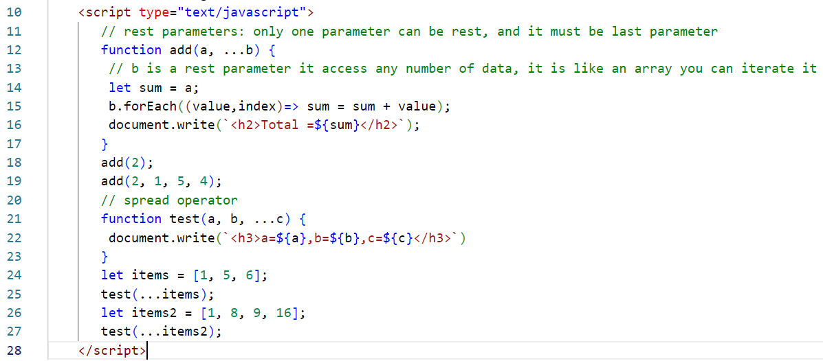

Output:

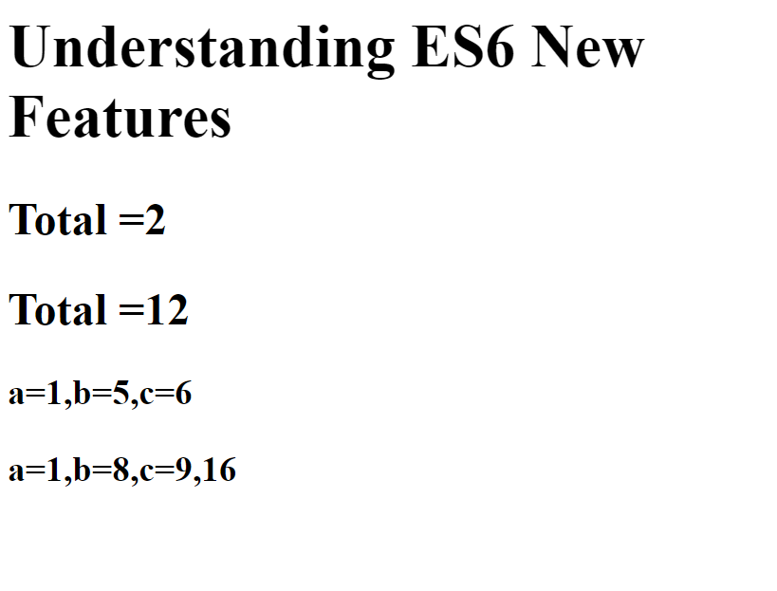

Destructuring: This helps in unwrapping the elements in the objects or arrays into another variables.

* Object Destructuring
* Array Destructuring

old approach

employee = {id:100, name: ”Rajesh”, salary:45000, email:”raj@g”, address : {st:”ka”,ct:”bl”} } ;

let id = employee.id;  
let name = employee.name;  
let salary = employee.salary;  
let email = employee.email;

New approach: Object destructuring

let { id, name, salary, email, address } = employee;   
let {st, ct } = address;  
console.log(st); // ka

Array Destructuring

Old approach uses index

let iplTeams = [“RCB”, “CSK”, “KKR”, “GT”];  
let r = iplTeams[0];  
let c = iplTeams[1];

New approach uses Destructuring  
let [a, b, c, d] = iplTeams;

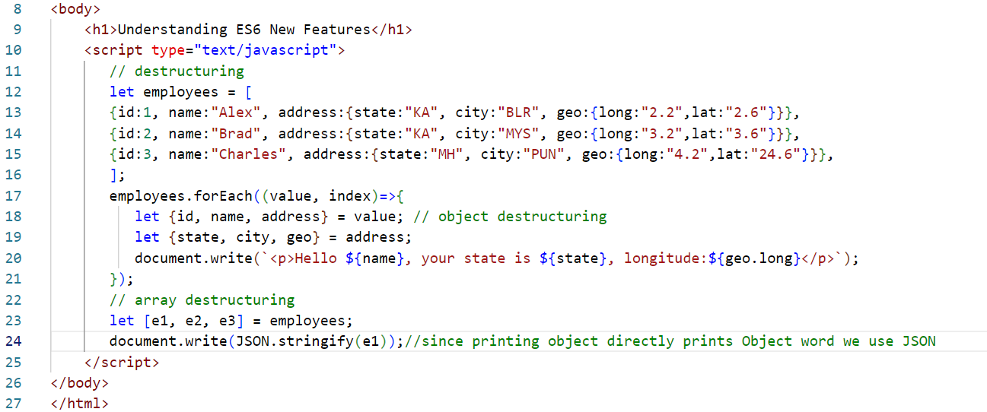

Output



Optional Chain

Whenever you access nested properties you need to be careful because there could be chance of type errors

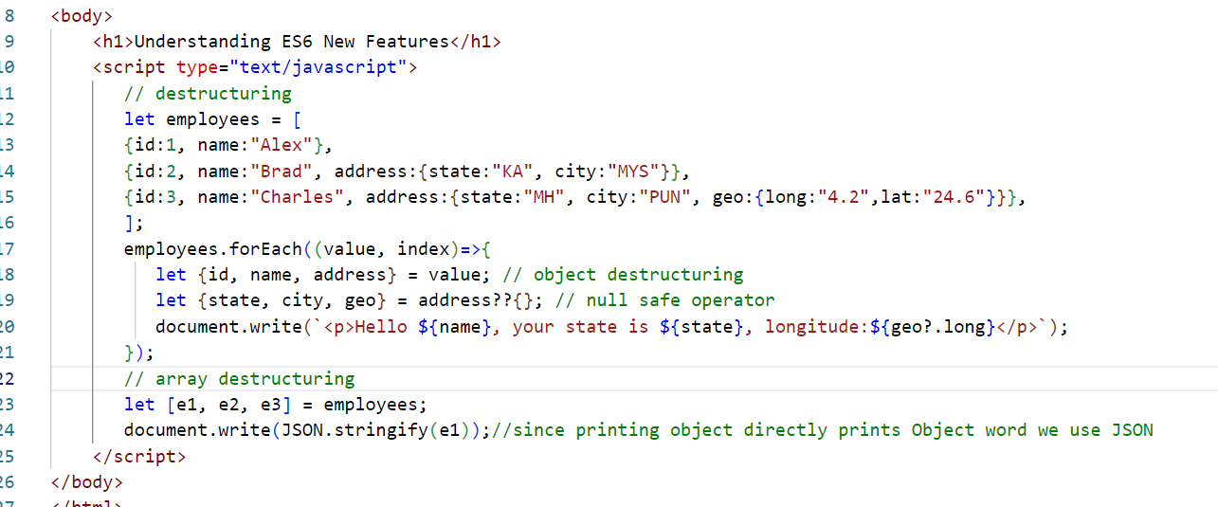

Output:

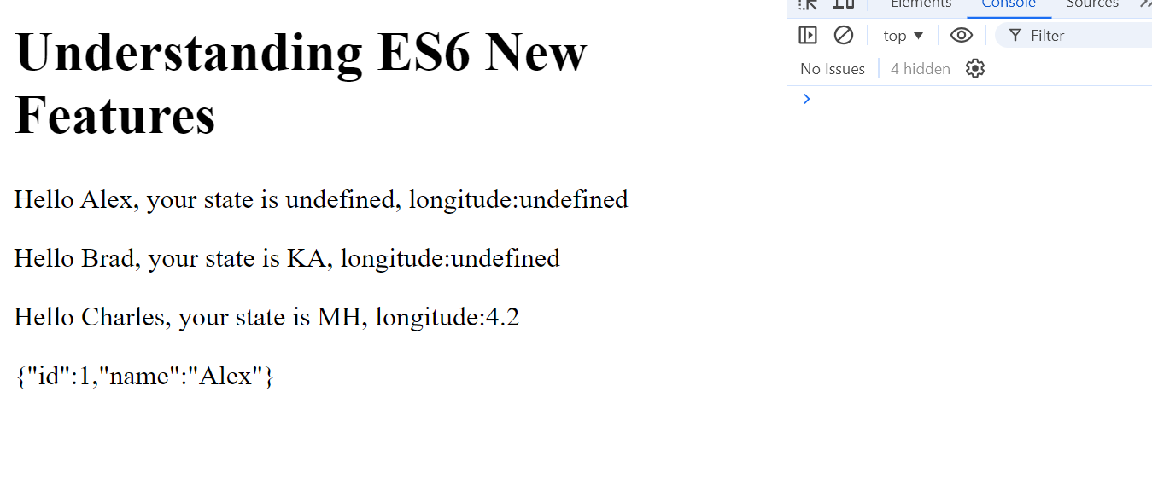

String padding start & end

9998889xxxx  
xxxx88989

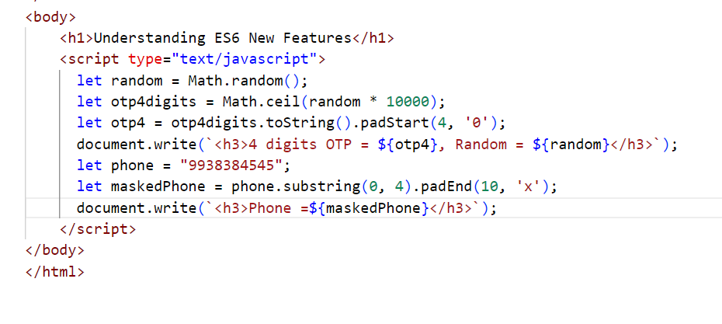

Output:

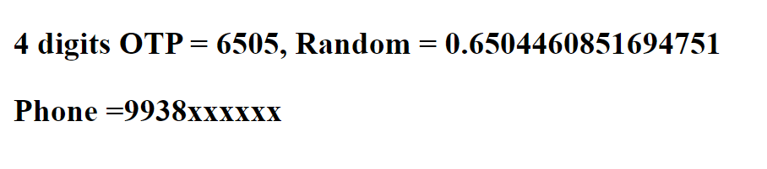

canvas element:

It is mainly to create 2d shapes

<canvas width=”400” height=”400” id = “c1”></canvas>

Promises

These are objects that make asynchronous requests and gets the response which can be either success or errors, if success its called promise is resolved, if error its called promise is rejected

You will use two methods of promise that takes callback functions as parameters

.then(callback)  
.catch(callback)

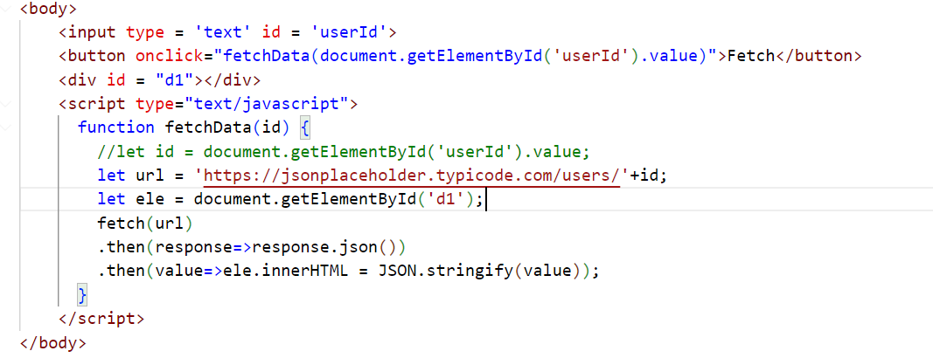

Output:

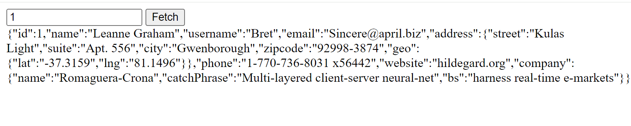

Async/Await

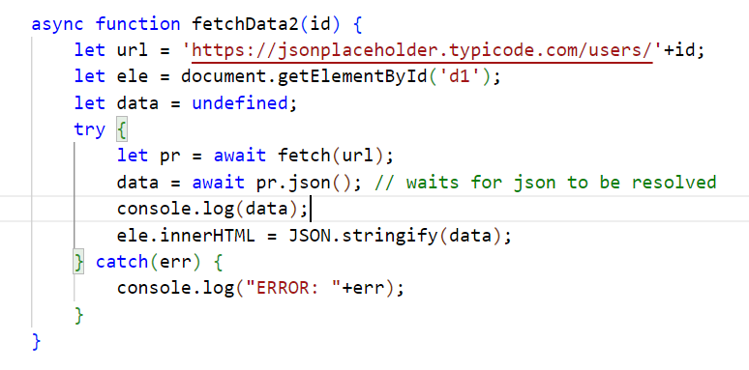

setters & getters

set & get keyword is used to create write & read functions

React.js

It is used to develop Single Page Applications(SPA), it is a Javascript library that helps you to create rich UI’s for your web page.

SPA:

Everything happens in one page, any changes you make that modifies only part of the page without reloading entire page

Components: These are independent UI’s which you can reuse in any part of the page.

Technologies react uses

1. HTML
2. JSX: Javascript XML: It makes you write HTML easily in the Javascript

Software’s required

1. VS Code
2. Babel toolkit -> Converts JSX to Javascript
3. Node.js & NPM

Libraries

Below are the libraries React.js uses

1. React: It is to create components & other react related features
2. React DOM: It is a virtual DOM
3. Babel: It is a transpiler to convert JSX to Javascript

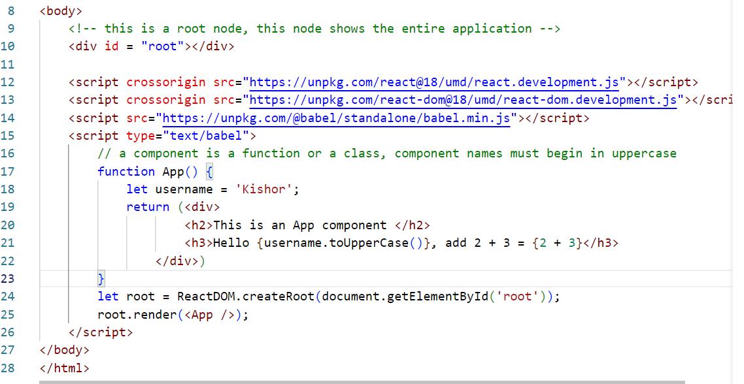

Virtual DOM

React uses this Virtual DOM to compare the content with the Real DOM of the browser and update only the changes required without reloading the DOM tree.

Without Virtual DOM

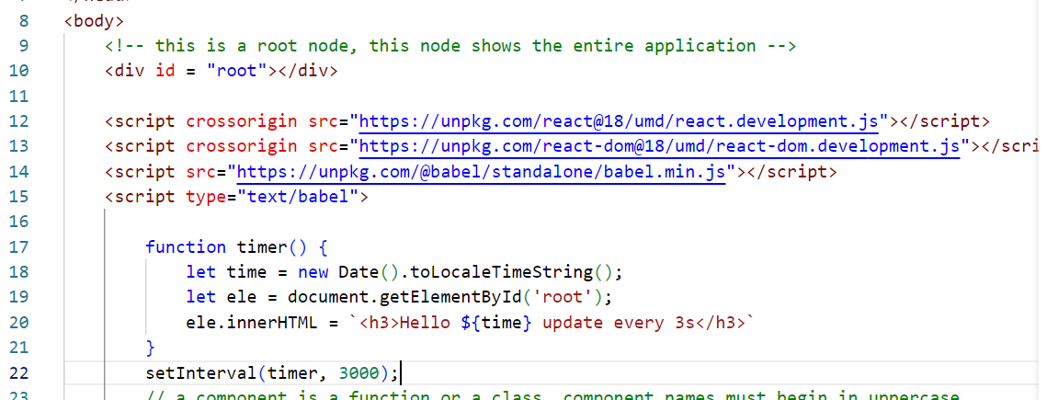

Output: You see entire DOM tree getting reloaded

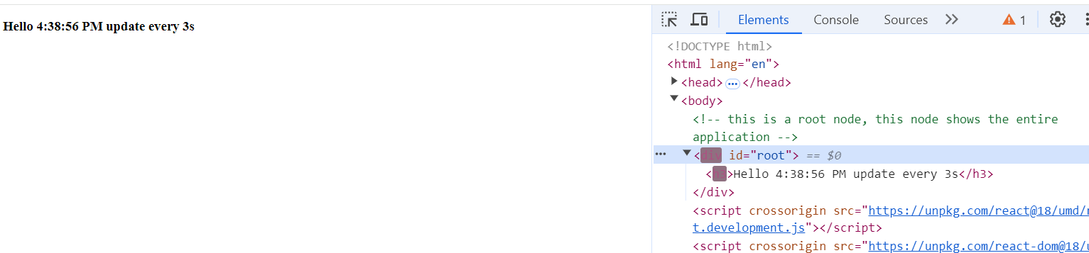

With Virtual DOM

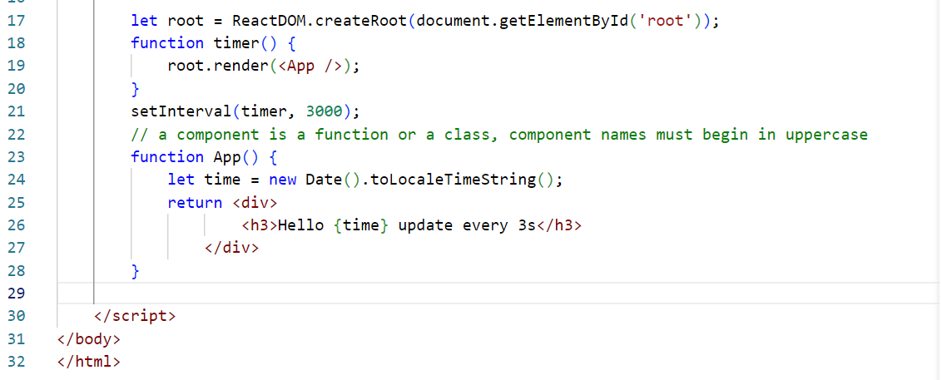

Output: You will see only time part is updating not the entire div or h3

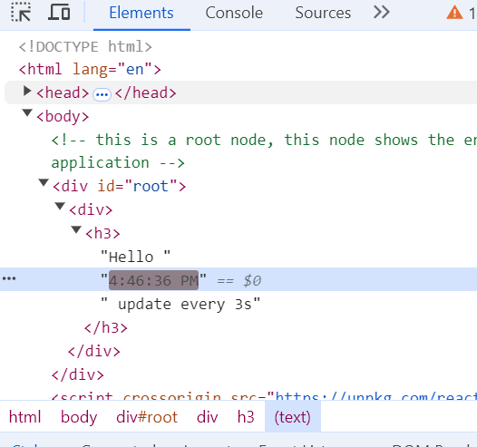

React Tool Kit

It is used to create an industry standard react application, it gives inbuilt structure like

* node_modules: to maintain all the libraries
* src: to keep all the source code
* package.json: to keep the project dependencies & commands to maintain the application

npx create-react-app myapp

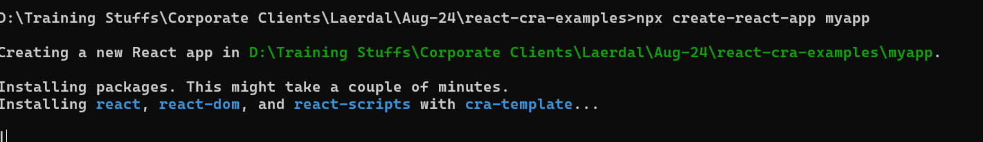

React Tool Kit

* It helps you to quickly create industry standard react applications
* It will have inbuilt live server which can auto-detect the changes
* It will have transpiler to convert JSX to Javascript
* It will be having GIT configuration as well, it will be in version control
* It will have project structure that separates HTML, CSS, Javascript, Libraries
* It will have package.json file that maintains application configurations

Command:

npx create-react-app myapp1

npm start: This starts the react application

Change in App.js

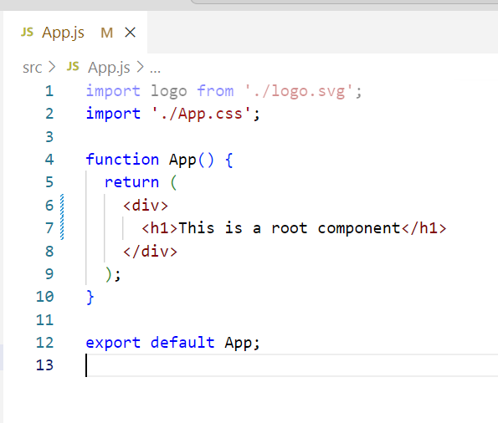

Output:

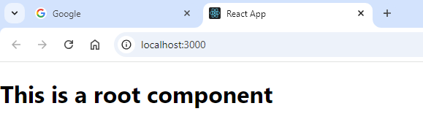

Let use custom components

There are two ways you can create components

1. Through classes that extends React.Component
2. Through function

src/MyComponent.js

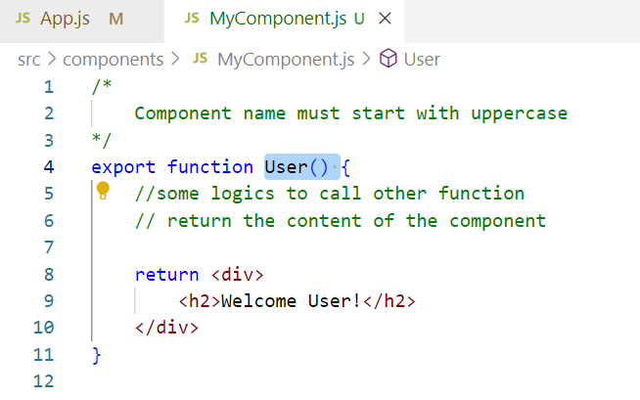

src/App.js

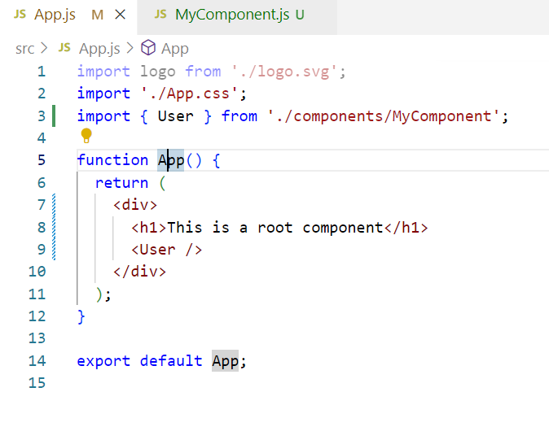

Props: These are input given to the components from another component, i.e., passing data from one component to another component

<User name = “Alex” age = 35 /> // props = {name:Alex, age:35 }  
<User name = “Rajesh” age = 45 /> // props = {name:Rajesh, age:45}  
 <User /> // props = undefined

function User(props) {   
 let name = props.name;  
 let age = props.age  
}

Passing props

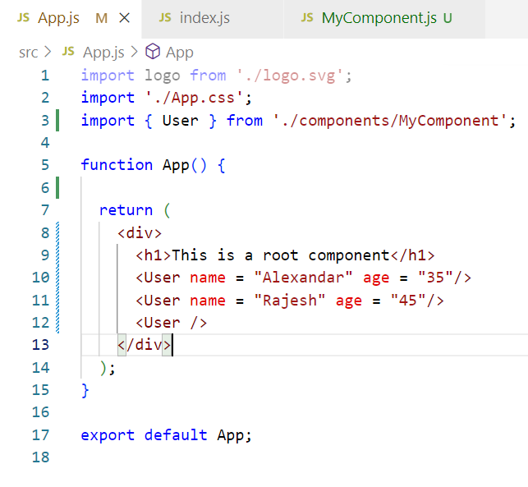

Conditional rendering

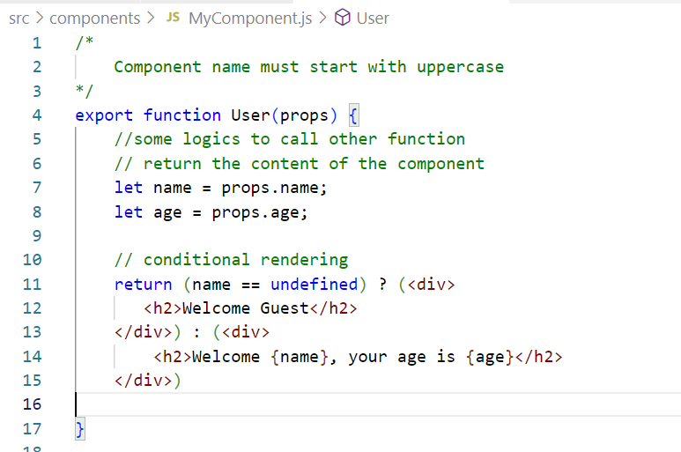

Output:





Splitting components into smaller components

MyComponent.js

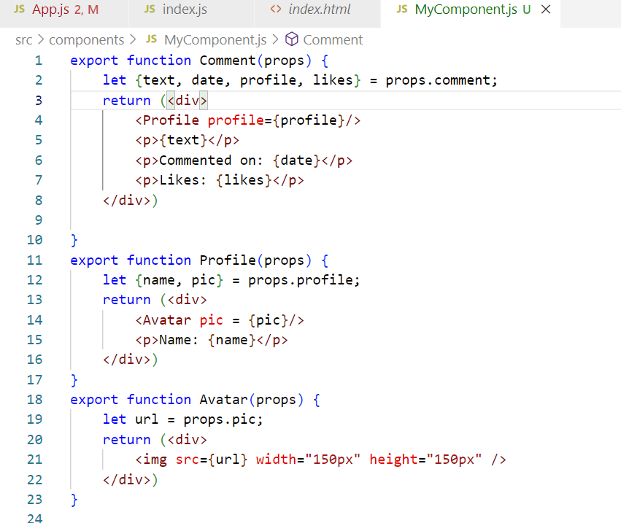

App.js

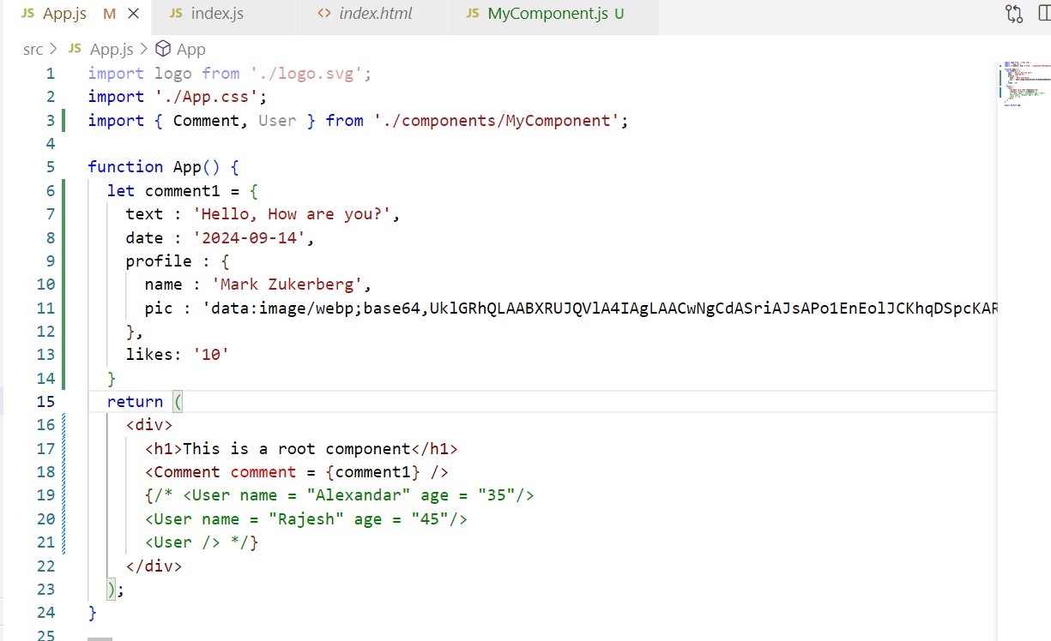

How to add styles in the react applications

You have css files like

App.css: It is for Root component i.e., App

index.css: It is a global style that is available for all the components, this is imported in index.js

We can add 3rd party css into our project

Note: It’s not recommended to add the CDN link, it is always better to download the css files and import in your project

npm install bootstrap

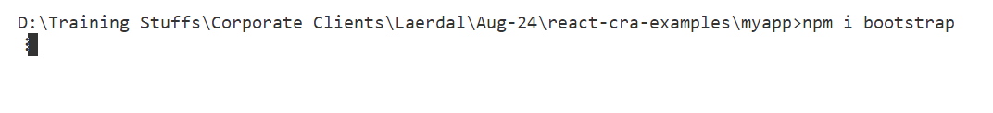

index.css

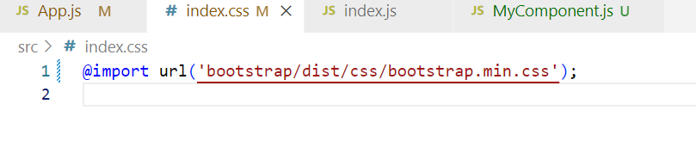

Can we create a css for a particular component

Answer: Yes

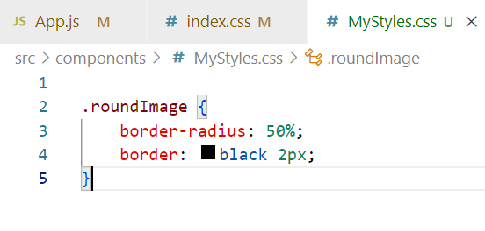

MyComponents.js

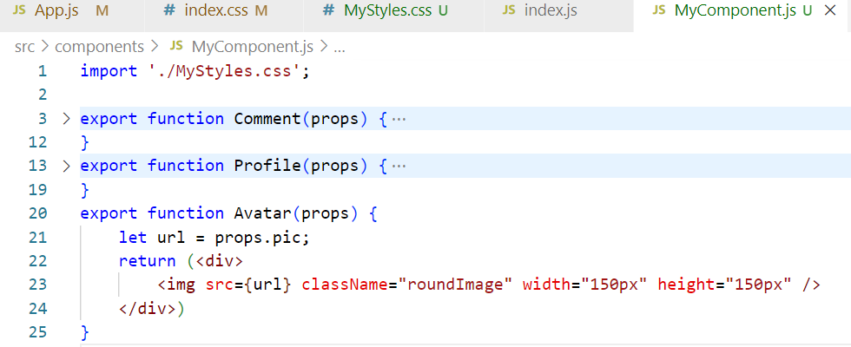

List & Keys

List is a collection of data, which you can render using map function, whenever you iterate the list you must use an unique key which helps in identifying any changes happening in the list.

listOfPlayers = [ “Virat”, “MS Dhoni” ,”Rohit”, …] ;  
employees = [ { ] ;

<ol>

listOfPlayers.map( (value, index) => { <li key = {index}>{value}</li>} );

</ol>

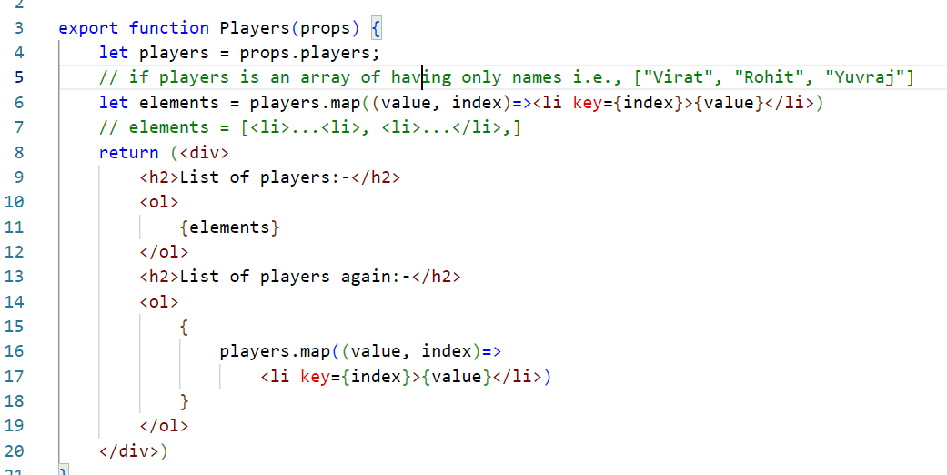

App.js

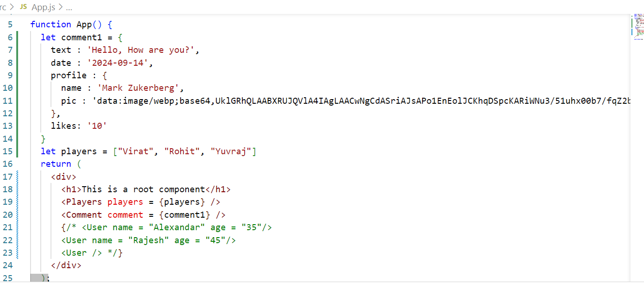

Array of complex objects

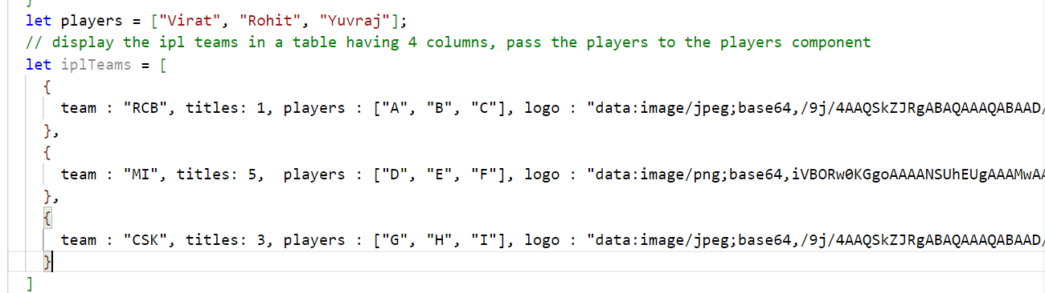

Rendering with nested components

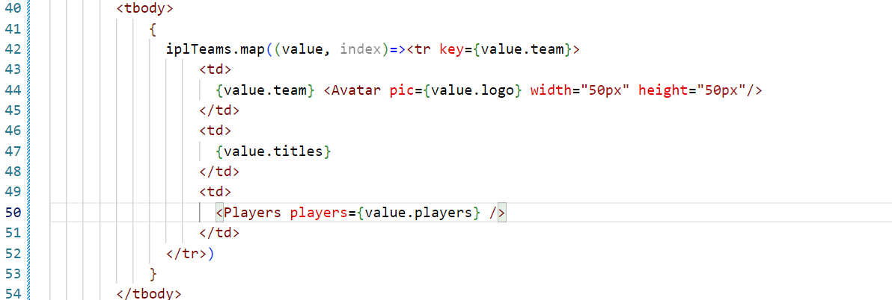

Event Handling & States in React

We can handle events in react similar to the way you handle in javascript, but the name the events should be camel case in react

|  |  |
| --- | --- |
| Event Names | React Event Names |
| onclick, ONCLICK, onClick | onClick |
| oninput, ONINPUPT | onInput |
| onchange | onChange |
|  |  |

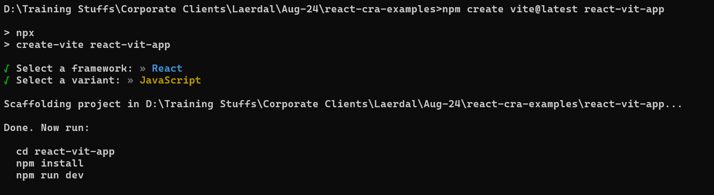

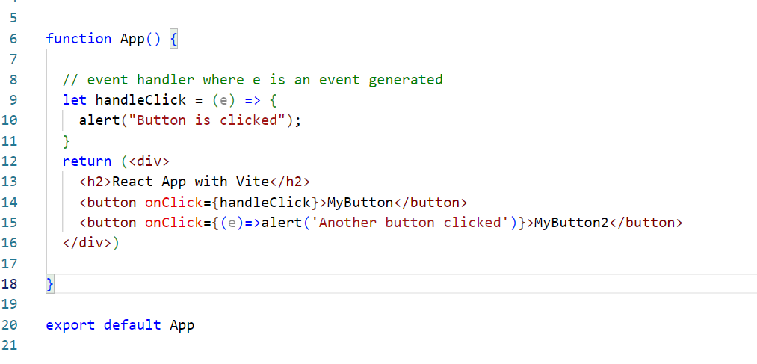

Inline & Named event handlers

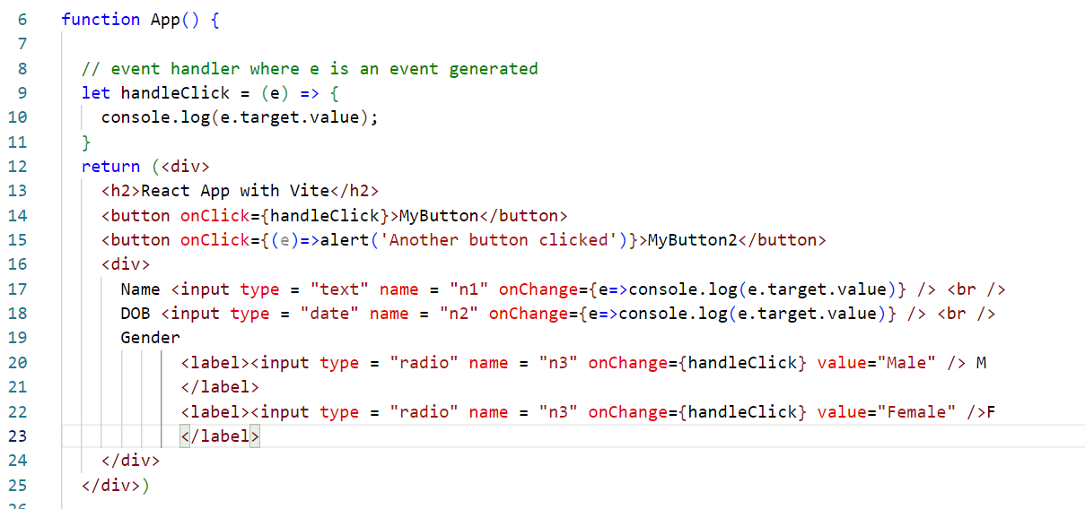

States:

Components can maintain the data in two forms

1. props: Read-only which you can’t modify, it is an input comes from different component
2. states: Read & Write both, it is used to store the component data like form data, backend data

Before React 16.8 state was present only in the class components & function components were just read-only, but after 16.8 react community added hooks which are some special function to support states in the functions.

useState: It is a hook function used to create states in the function component

let [name, setName] = useState(“”); // name = “” by default

setName(“Raj”); // name=”Raj”;

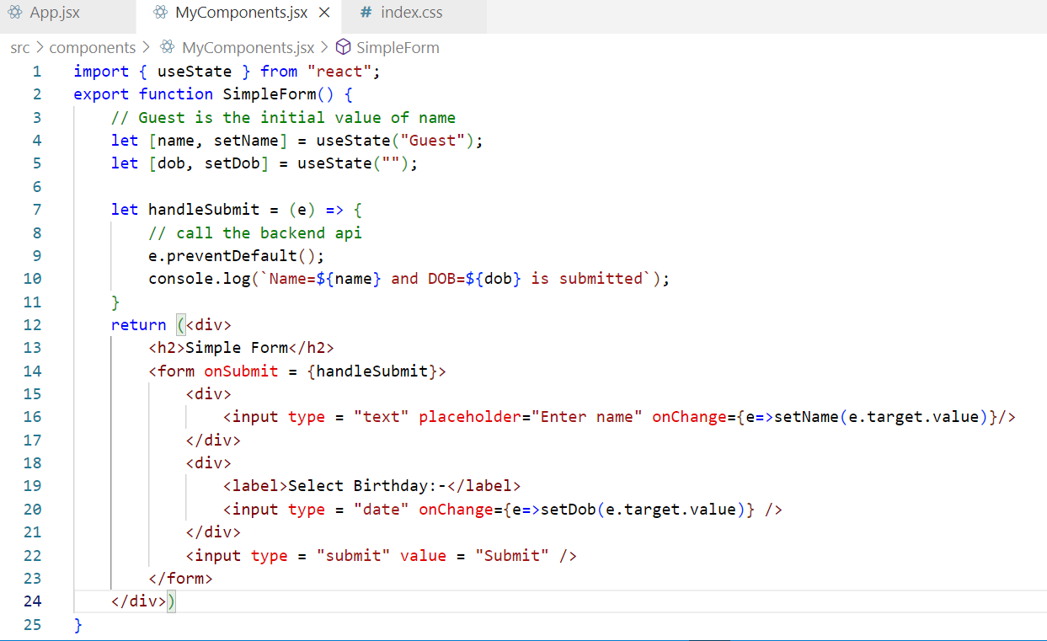

Output:

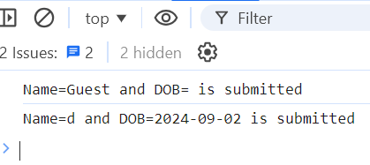

For checkbox

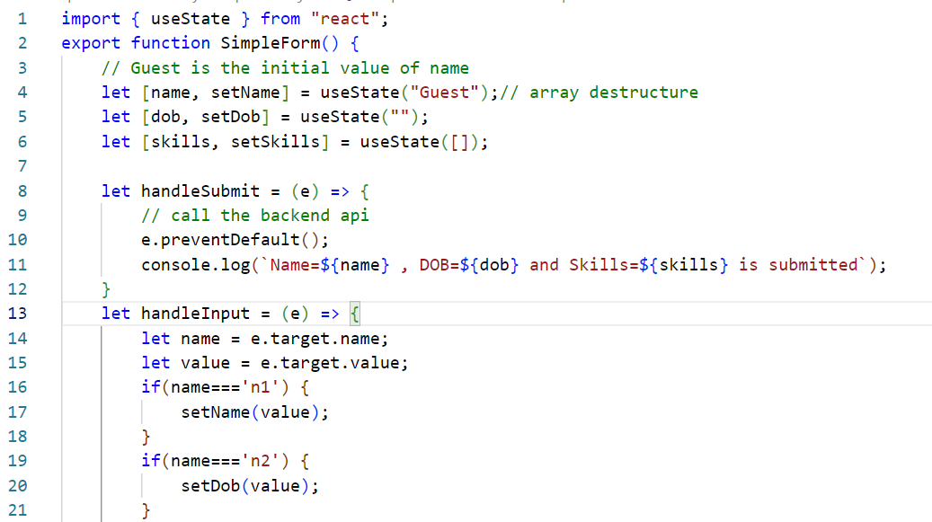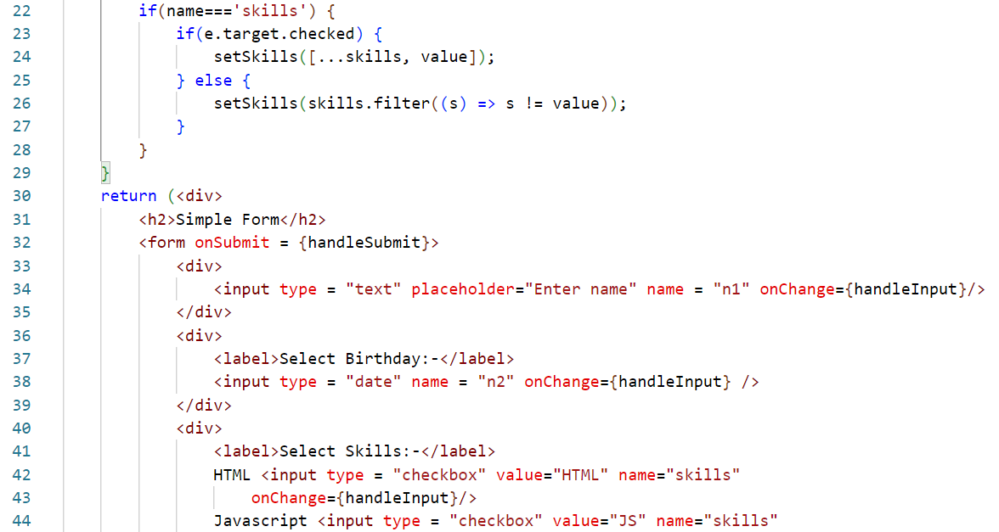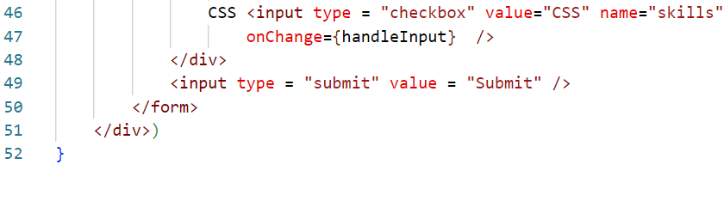

Class based components

React introduced two ways to create components

1. Class based
2. Function based

Components via Classes

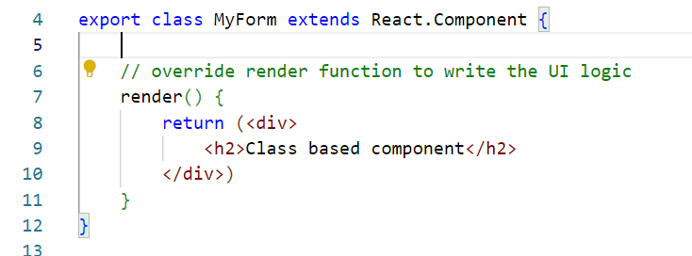

In class you get a state property inherited that can be used to maintain the state & setState() method must be used to modify the states

* You must initialize the state in the constructor
* Constructor must accept the props and pass to the super class to initialize the props

constructor(props) { super(props); this.state = {name:””, age: “” }}

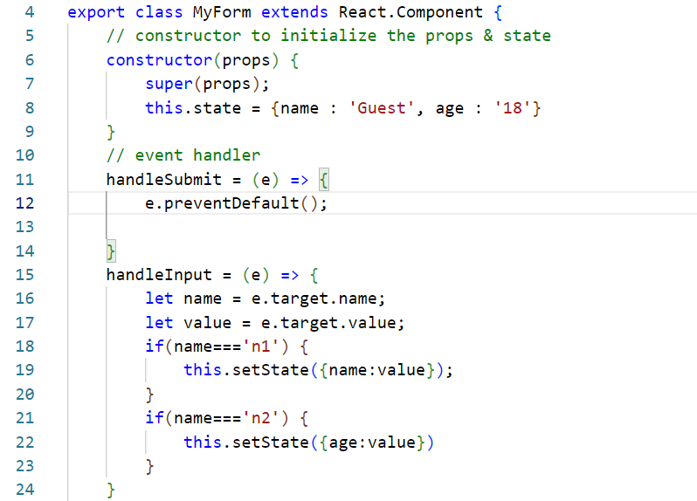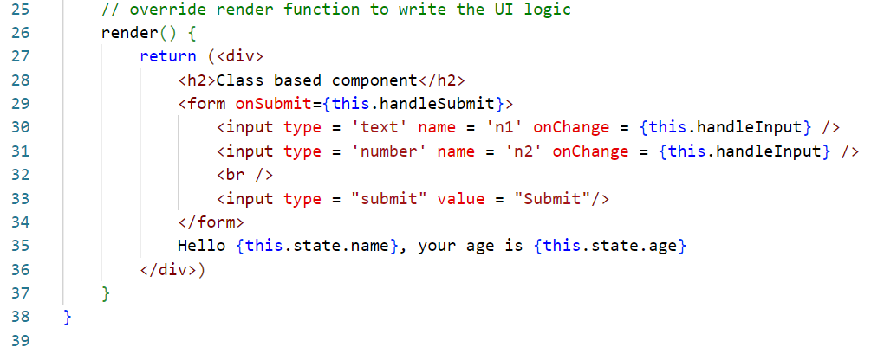

Differences between class & function based components

Before React 16.8 function components didn’t have state, life-cycle methods features, to use these features you must use class-based components

|  |  |
| --- | --- |
| function | class |
| Stateless components before 16.8 | Stateful components |
| functions support states from 16.8 onwards through useState | classes supports states using state & setState methods that are inherited |
| function supports life cycles methods through hook functions from 16.8 onwards ex: useEffect(), useContex() | class supports life cycle methods through the inherited methods |
| function will have the UI logic | render() will have the UI logic |